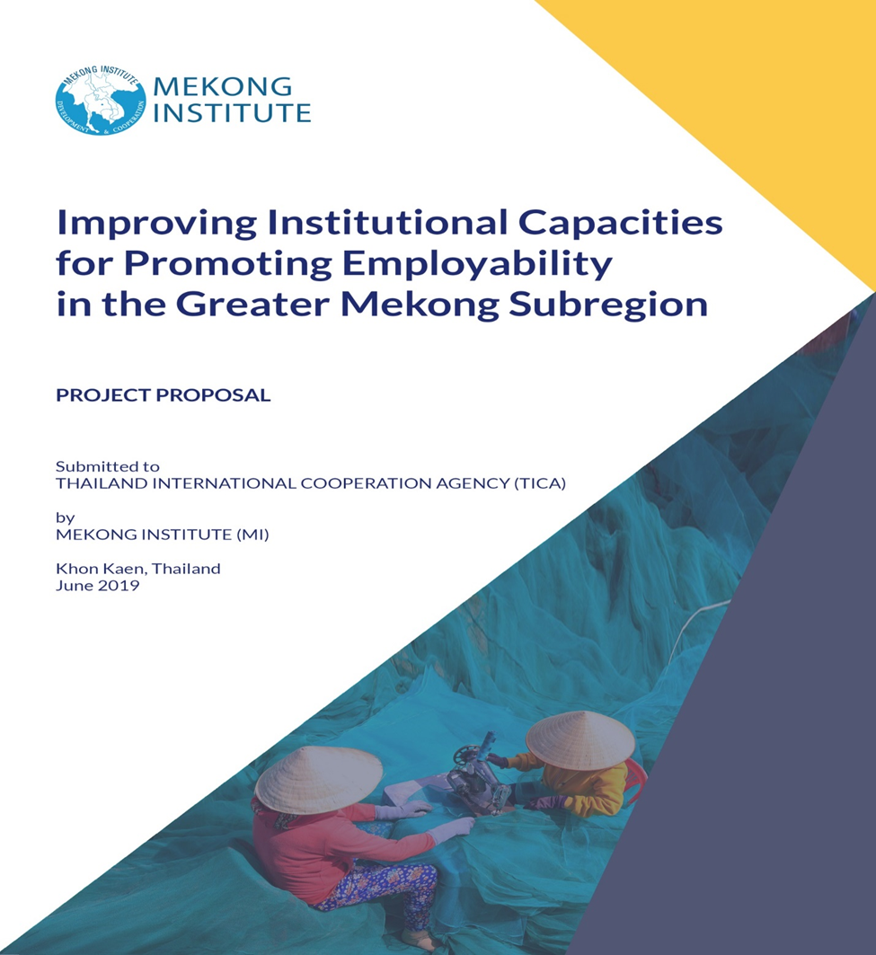



Appendix 2:

Regional Public-Private Consultative Workshop

Enhancing Private Sector Engagement in Improving Employability of CLMV Workforce

June 21-22, 2021

Organized by Mekong Institute (MI)
in Collaboration with
Thailand International Cooperation Agency (TICA)

Background

The national peer-to-peer learning programs organized in December underscored that CLMV Countries are moving towards adopting competency-based skill development system. By learning insights from the Thai expert and the regional experts, the CLMV representatives reflected the good practices and shortcomings in their existing systems. By and large, it was found that CLMV countries have certain similar policies and mechanisms in place for quality assurances, assessments and developing relations with stakeholders. Nonetheless, there has been policy implementation gap provided the scarce allocation of public resources. Additionally, the complexity of interacting factors among different political, economic, social and education structures also caused the delivery challenges to keep up with the changing labour market. The weakness of collaborative policy consultation culture remains one of the contributing factors for subsequent implementation difficulties. Even though there is no one-size-fit-all model for workforce development, the key interest shared by the regional labour officials and skill providers in the national workshops was to promote more effective engagement of private sector in skill provision.

In light of the ongoing pandemic in which the onsite activities are not viable for implementation, the upcoming component is devised as a virtual public-private consultative workshop in order to support the shared interests of the regional beneficiaries. In addition to the representatives who joined the respective national workshops in December, this regional workshop will bring business communities and non-profit organizations that are involving in skill provision schemes in Thailand. Furthermore, the business communities will also include Thai investors in economic zones/ industrial parks of CLMV countries. It would ultimately support in drawing evidence-based recommendations for skill development institutes to improve their efforts in producing competitive workforce in their respective countries.

Objectives
- To deepen understanding on the far-reaching benefits of cooperation between Industry and skill development institutes
- To strengthen the relations between public sector and industrial sector
- To support the employability of labour force in special economic zones and prospective
investment areas of CLMV countries

Number of Targeted Participants: 50 Participants from CLMV countries

Tentative Agenda

 | Indicative Timing | Agenda Items | Resource Persons/ Moderators
Day1: June 21, 2021
1. | 09:00-10:00  10.00-11.00 | Opening and Setting the context  Walking through Enhancing Employability in CLMV  - Findings of the Previous Workshop  - Rationale of the Regional Workshop  Labour Demand and Skill Supply in CLMV | MI and RPs
2. | 11:00-12:00 | - Situation of Private Sector Engagement in Thailand  - Situation of Private Sector Engagement in Cambodia  - Situation of Private Sector Engagement in Lao PDR | MI and RPs
 | 12:00-13:00 | Lunch Break
3. | 13:00-14:00 | - Situation of Private Sector Engagement in Myanmar  - Situation of Private Sector Engagement in Vietnam  - Wrap-Up | MI and RPs
 | 14:00-15:00 | Discussion | MI and RPs
4 | 15:00-16.00 | - Good Practices in Multi-stakeholder Coordination Mechanism Development (1) | MI and RPs
5 | 16.00-17.00 | - Success Story in Multi-stakeholder Governance in Skill Development | MI and RPs

 | Indicative Timing | Agenda Items | Resource Persons/ Moderators
Day 2: June 22, 2021
1. | 09:00-10:00 | TVET under Education and TVET under Labour  - Coordination Case Study in Thailand | MI and RPs
2. | 10:00-12:00 | Country Discussion on Enhancing Private Sector Engagement (Break-Out Discussion)  Breakout Room with Cambodia moderated by Mr. Sudam Pawar  Breakout Room with Lao PDR moderated by Dr. JJ  Breakout Room with Myanmar moderated by Than Tha Aung  Breakout Room with Vietnam moderated by Ms. Vu | MI and RPs
 | 12:00-13:00 | Lunch Break
3. | 13:00-15.00 | - Presentation by Cambodia  - Presentation by Lao PRD  - Presentation by Myanmar  - Presentation by Vietnam  - Questions and Answer | MI and RPs
 | 15.00-15.30 | Discussion | RPs and Participants
4 | 15.30-16:30 | Action Plan and Q&A | MI and RPs
 | 16.30-17.00 | Regional Analysis and Recommendations  Way Forward | RPs and Participants

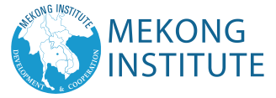

MEKONG INSTITUTE
123 Mittraphap Road, Muang District
Khon Kaen 40002 THAILAND
Tel: + 66 (0) 43-202-268, 269, 270
Fax: +66 (0) 4334 3131
Website: www.mekonginstitute.org
Email: information@mekonginstitute.org

